**Android**Version: **2.0.37 / iOS**Version: **1(50)**

Android:

1. Help Page - "Mailto" is not enabled (Please view attached video)
2. ID – “Use only alpha and number” is not displayed fully in android

1. Msg in/out - for a new registered user displayed as toggled "out" but received messages when trips were booked.

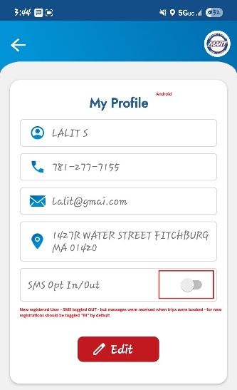

3. Fares and passes icon is not available in fixed routes

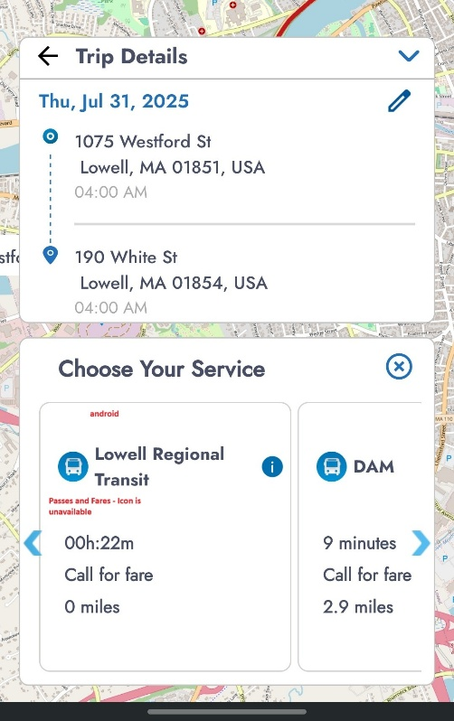

1. Time window and 20miles restriction is not displayed on clicking on "MT Service" is displayed in the next page after clicking on "Book Trip"

6. Manage credit cards - Google Pay is available as option

IOS:

1. Fixed Routes – Display the full name as in Android

1. When no fixed routes are available can it display the message “No Routes available” as in previous version?

